J. angielski – 3, 4 latki
Propozycje zadań

- Piosenka na powitanie
https://www.youtube.com/watch?v=gdeB9kDT6uI

- Ubrania/Clothes: shirt, dress, trousers, cap, shoes

- Utrwalenie piosenki

Piosenka:

I’m wearing two shoes, two shoes, two shoes.
I’m wearing two shoes, look at me.
I’m wearing trousers, trousers, trousers.
I’m wearing trousers, look at me.
I’ wearing a big shirt, a big shirt, a big shirt.
I’m wearing a big shirt, look at me.

- Pokoloruj ubrania. Policz ile jest skarpet? Podaj liczę w języku angielskim.

- Piosenka na pożegnanie
https://www.youtube.com/watch?v=2O975ewRT7Q
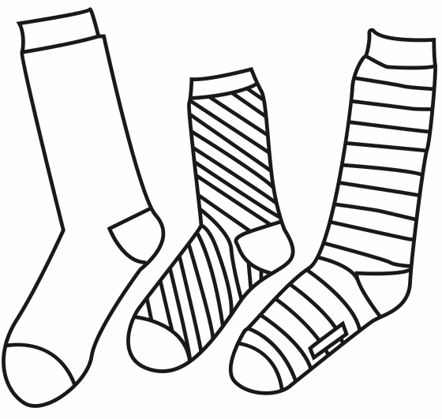

SOCKS
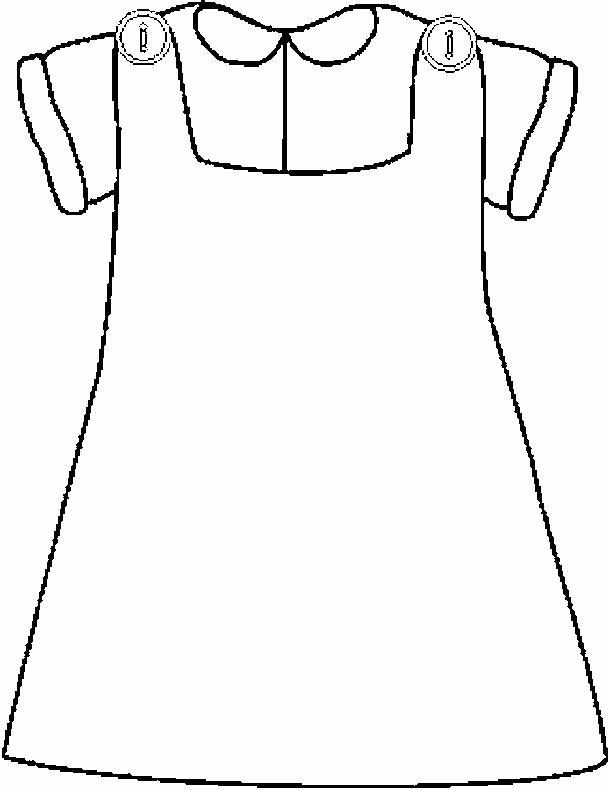

DRESS

